Student | Mr. Rob
 |  | Title slide with Name | Teacher | Topic
 |  | Correct spelling and grammar
 |  | Ten informative captions providing information, not just labels
 |  | Captions/text is readable
 |  | At least four minutes long
 |  | Music plays throughout; song is related to topic
 |  | Pictures don’t last for more than 4 seconds each
 |  | Contains a picture of yourself right in the middle of the video
 |  | Video has been uploaded to YouTube
 |  | No imported video clip lasts longer than 20 seconds each
 |  | Pictures are arranged in some kind of order (relating to lyrics), not just randomly thrown in
 |  | Link to YouTube video has been emailed to Mr. Robinson (seanshistory@gmail.com)
 |  | Video is physically brought on a USB stick (extension ends with .wmv, not whm)
 |  | Bonus Points: Pictures are lined up with the lyrics/rhythm of the song
 |  | Bonus Points: Includes one or many imported video clips (save a YouTube video and import and edit it)

❒ American Idol Version
Student | Mr. Rob
 |  | Title slide begins with Name | Teacher | Topic
 |  | Lyrics are typed on screen
 |  | Lyrics are readable
 |  | Correct spelling and grammar
 |  | Song and lyrics shows an understanding of your topic
 |  | At least 2 minutes and 30 seconds long (please, go longer if you want)
 |  | You can either do a slideshow with images about your topic or video of you performing
 |  | Video is uploaded to YouTube
 |  | Link to YouTube video has been emailed to Mr. Robinson (seanshistory@gmail.com)
 |  | Video is physically brought on a USB stick (extension ends with .wmv, not whm)
 |  | Bonus Points: Pictures are lined up with the lyrics/rhythm of the song
Stuff That Can Help You
How to create movies with Windows Movie Maker: http://presentationsoft.about.com/od/moviemaker/a/mov_mak_beg.htm
Download Windows Movie Maker:
http://windows.microsoft.com/en-US/windows/downloads/get-movie-maker
Or google: “download movie maker”
Use: http://www.mediaconverter.org/ to save YouTube videos as WMV files so you can import them in your project. You can also use the above link to save YouTube mp3s (audio) so you can use the music to karaoke new lyrics.
Steps to Creating a Performance American Idol Video
1. Figure out what song you're going to use. Search on YouTube for that song in an instrumental or karaoke version. When you've found it, copy the URL or link for that YouTube from the address bar.
It will look like this: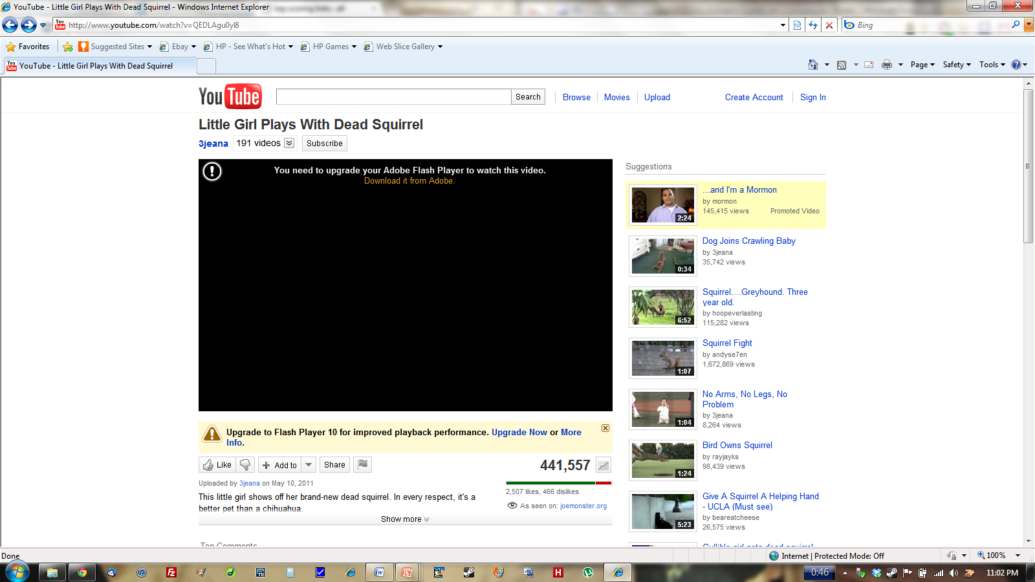
2. Go to a site that will rip the music from that video. A site I recommend is mediaconverter.org (there are many other sites that work too). Go there and save the YouTube audio as an mp3 file.
3. Time to record yourself singing with your history lyrics. You'll need a webcam, iPod with recording capabilities, or something like that. Alternatively, you could just record the audio of your singing with a mic. I recommend playing the YouTube instrumental version in the background very low so that you can stay on cue.
4. Import what you've done into Windows Movie Maker. Open Movie Maker and select import video and select your video you just recorded. Then select import audio and select the YouTube mp3 you downloaded. Should sound professional. You may need to re-record your singing or time the mp3 just right so everything is on cue.
5. In Movie Maker, you can add captions which can serve as your lyrics. Just add the caption and edit the time so that it shows up just as you're saying those words on screen.
Steps to Creating a Slide Show American Idol Video
1. Record the audio of yourself singing your song. Create a wav file or mp3. Can be done with iPhone, iPod, Windows sound recorder, etc. (I recommend audacity @ http://audacity.sourceforge.net) This time I recommend playing the YouTube instrumental version very loud and at the same time you sing into a mic somewhere.
2. Download a ton of pictures from the internet relating to your topic. For example, for French Revolution, I'd download King Louis XVI, Robespierre, guillotine, etc. Try to download pictures that you specifically mention in your song.
3. Open Windows Movie Maker and add those pictures to your timeline. Then import your audio you recorded. Line up your pictures with the exact moment you mention them in your song. For example, when you mention King Louis, show a picture of King Louis.
4. Add lyrics to your video so I know what you're saying. On Windows Movie Maker, click "Add Captions."

